**Lab #7**

1. For the first question, we are being asked to determine which material the system should be made of to sustain the force ‘P’ and not have the vertical bars elongate by 0.1% of their individual original lengths. A good answer for this question will be so that one of the three materials were selected and there was enough proof (graphically, for example) to prove why the specific material was picked. For the second question, we are being asked to determine the distance the weight of the horizontal bar should be at in perspective to point A, to make sure that the bar remains horizontal. As the ‘d’ distance increases, I expect that the bars that ‘P’ is approaching will have increasing elongations and the bars that ‘P’ is moving away from will face smaller and smaller elongation. We predict as ‘d’ increases, AD will elongate less and less, while BE and CG will increasingly elongate.
2. For the first question, it would be useful to construct a matrix out of the 3 linear equations that are given. It will also be useful to replace the “**ΔL” with an equivalent expression in terms of ‘F’ which is also provided in the problem. This will allow all three equations to be in terms of the 3 different forces of the bars. Knowing that part of the equation involves the variable ‘d’, we should test multiple values of ‘d’ as it increases from 0-16 to determine which material would not elongate more than 0.1% for all values of d. To calculate every value of ‘d’ would be tedious, so we could make use of the for loop and increase d by 0.1 to have a reasonable number of test values. The following steps can be placed within the loop. With such a matrix, it is possible to use Matlab to solve for the forces that would fit the system. Once the forces are calculated, we can use those forces to calculate the individual bar elongations and further use those values to determine what percent of the original length have they elongated. If they elongate more than 0.1%, then we can determine the system should not be made of that given material. Plots that would be helpful for this question would be a scatter plot to plot individual elongation values for increasing ‘d’ values.**

**For the second question, the process is very similar. After finding the solution for the given matrix and knowing which material the bars are going to be made of, we can determine at what ‘d’ value would the elongation for all the bars be the same. Since AC is horizontal before the elongation, if the elongation of all the bars are the same, then AC would remain horizontal. Using the graph we produce, we will be able to find the ‘d’ value for which the elongation for all the bars are the same and hence AC would remain horizontal.**

1. Based off the steps above, we have created the following code for question 1:

figure(1)

title('Aluminum Alloy 1100');

xlabel('d (m)');

ylabel('Elongation %');

for d=0:0.1:16

A=[1,1,1;0,10,16;(6/7500000),(-16/6000000),(10/15000000)];

B=[90000;(90000*d);0];

x=linsolve(A,B);

ad=(x(1)*4)/(75000000000*0.0004);

be=(x(2)*5)/(75000000000*0.0004);

cg=(x(3)*2)/(75000000000*0.0004);

ad_percentage=(ad/4)*100

be_percentage=(be/5)*100

cg_percentage=(cg/2)*100

hold on

grid on

plot(d,ad_percentage,'r.')

plot(d,be_percentage,'b.')

plot(d,cg_percentage,'y.')

legend('Delta L for AD','Delta L for BE','Delta L for CG');

end

figure(2)

title('Nickel 200');

xlabel('d (m)');

ylabel('Elongation %');

for d=0:0.1:16

A=[1,1,1;0,10,16;(6/20900000),(-16/16720000),(10/41800000)];

B=[90000;(90000*d);0];

x=linsolve(A,B);

ad=(x(1)*4)/(209000000000*0.0004);

be=(x(2)*5)/(209000000000*0.0004);

cg=(x(3)*2)/(209000000000*0.0004);

ad_percentage=(ad/4)*100

be_percentage=(be/5)*100

cg_percentage=(cg/2)*100

hold on

grid on

plot(d,ad_percentage,'r.')

plot(d,be_percentage,'b.')

plot(d,cg_percentage,'y.')

legend('Delta L for AD','Delta L for BE','Delta L for CG');

end

figure(3)

title('Steel Alloy 4340');

xlabel('d (m)');

ylabel('Elongation %)');

for d=0:0.1:16

A=[1,1,1;0,10,16;(6/19700000),(-16/15760000),(10/39400000)];

B=[90000;(90000*d);0];

x=linsolve(A,B);

ad=(x(1)*4)/(197000000000*0.0004);

be=(x(2)*5)/(197000000000*0.0004);

cg=(x(3)*2)/(197000000000*0.0004);

ad_percentage=(ad/4)*100

be_percentage=(be/5)*100

cg_percentage=(cg/2)*100

hold on

grid on

plot(d,ad_percentage,'r.')

plot(d,be_percentage,'b.')

plot(d,cg_percentage,'y.')

legend('Delta L for AD','Delta L for BE','Delta L for CG');

end

The code above produces the following graphs:

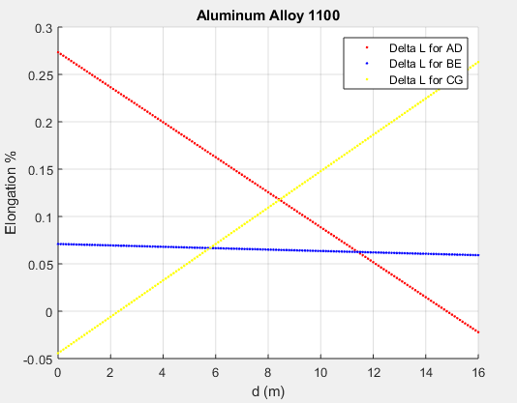

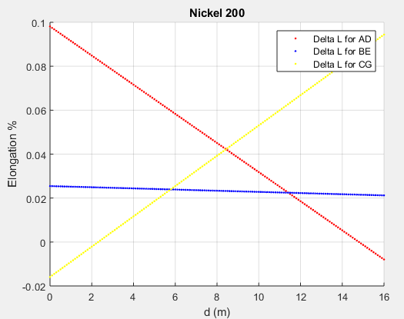

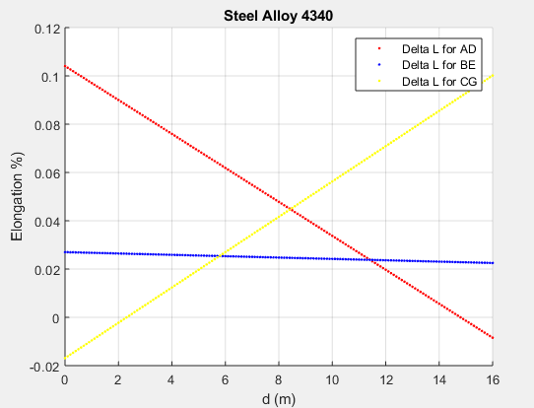

The graphs above show the elongation percentages for each of the bars (AD – red, BE – blue, CG – yellow) for each of the three materials. Since the elongation percentages for Aluminum and Steel are higher than 0.1% for certain values of d, the system can not be made of these materials. Only Nickel fits the description of having elongation for all the bars being less than 0.1%. Therefore, Nickel can be used for all the vertical bars to ensure that for P=90kN and any value of ‘d’, none of the bars elongate by more than 0.1%.

Based off the steps for Question 2 and knowing that Nickel was the answer for the first question, we created the following code:

figure(2)

title('Nickel 200');

xlabel('d (m)');

ylabel('Delta L (m)');

for d=0:0.1:16

A=[1,1,1;0,10,16;(6/20900000),(-16/16720000),(10/41800000)];

B=[90000;(90000*d);0];

x=linsolve(A,B);

ad=(x(1)*4)/(209000000000*0.0004);

be=(x(2)*5)/(209000000000*0.0004);

cg=(x(3)*2)/(209000000000*0.0004);

hold on

grid on

plot(d,ad,'r.')

plot(d,be,'b.')

plot(d,cg,'y.')

legend('Delta L for AD','Delta L for BE','Delta L for CG');

end

This produces the following graph:

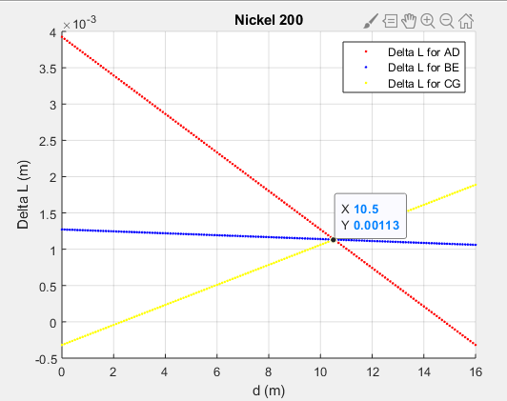

The graph above shows that at a ‘d’ value of 10.5m, the elongation for all the verticals is the same and all elongate by a value of 0.00113m. This means that the AC would remain horizontal at a ‘d’ value of 10.5m away from A.

1. Looking back, we see that we have solved the questions we were asked. We concluded that Nickel would be the material that would not allow the vertical bars to elongate by more than 0.1% and we also concluded that the weight on the horizontal bar should be located 10.5m away from A for AC to remain horizontal. Using our graphs, we have sufficient proof to support our answer as well as making sure the numeric computation makes sense. We had to consider what variables to have in our matrix so that the variables are constant. For example, we had to rewrite ‘**ΔL’ in terms of ‘F’ so that the system is consistent.**